**Noter App - Assignment**

Task1:Docker file

FROM node:14

WORKDIR /app

COPY package*.json /app/

RUN npm install nodemon -g --save

COPY . .

EXPOSE 4000

CMD [ "npm","start"]

Task2&3: Image creation with tag

docker build -t gowthamsammangi/mynoterapp:v1 .

[+] Building 31.1s (10/10) FINISHED docker:default

=> [internal] load build definition from Dockerfile 0.1s

=> => transferring dockerfile: 167B 0.0s

=> [internal] load .dockerignore 0.0s

=> => transferring context: 2B 0.0s

=> [internal] load metadata for docker.io/library/node:14 0.5s

=> [1/5] FROM docker.io/library/node:14@sha256:a158d3b9b4e3fa813fa6c8c590b8f0a860e015ad4e59bbce5744d2f6fd8461aa 25.3s

=> => resolve docker.io/library/node:14@sha256:a158d3b9b4e3fa813fa6c8c590b8f0a860e015ad4e59bbce5744d2f6fd8461aa 0.0s

=> => sha256:a158d3b9b4e3fa813fa6c8c590b8f0a860e015ad4e59bbce5744d2f6fd8461aa 776B / 776B 0.0s

=> => sha256:b253aeafeaa7e0671bb60008df01de101a38a045ff7bc656e3b0fbfc7c05cca5 7.86MB / 7.86MB 0.5s

=> => sha256:2cafa3fbb0b6529ee4726b4f599ec27ee557ea3dea7019182323b3779959927f 2.21kB / 2.21kB 0.0s

=> => sha256:1d12470fa662a2a5cb50378dcdc8ea228c1735747db410bbefb8e2d9144b5452 7.51kB / 7.51kB 0.0s

=> => sha256:2ff1d7c41c74a25258bfa6f0b8adb0a727f84518f55f65ca845ebc747976c408 50.45MB / 50.45MB 1.4s

=> => sha256:3d2201bd995cccf12851a50820de03d34a17011dcbb9ac9fdf3a50c952cbb131 10.00MB / 10.00MB 0.7s

=> => sha256:1de76e268b103d05fa8960e0f77951ff54b912b63429c34f5d6adfd09f5f9ee2 51.88MB / 51.88MB 2.4s

=> => sha256:d9a8df5894511ce28a05e2925a75e8a4acbd0634c39ad734fdfba8e23d1b1569 191.85MB / 191.85MB 5.7s

=> => sha256:6f51ee005deac0d99898e41b8ce60ebf250ebe1a31a0b03f613aec6bbc9b83d8 4.19kB / 4.19kB 1.6s

=> => sha256:5f32ed3c3f278edda4fc571c880b5277355a29ae8f52b52cdf865f058378a590 35.24MB / 35.24MB 3.1s

=> => extracting sha256:2ff1d7c41c74a25258bfa6f0b8adb0a727f84518f55f65ca845ebc747976c408 5.2s

=> => sha256:0c8cc2f24a4dcb64e602e086fc9446b0a541e8acd9ad72d2e90df3ba22f158b3 2.29MB / 2.29MB 3.5s

=> => sha256:0d27a8e861329007574c6766fba946d48e20d2c8e964e873de352603f22c4ceb 450B / 450B 3.7s

=> => extracting sha256:b253aeafeaa7e0671bb60008df01de101a38a045ff7bc656e3b0fbfc7c05cca5 0.5s

=> => extracting sha256:3d2201bd995cccf12851a50820de03d34a17011dcbb9ac9fdf3a50c952cbb131 0.4s

=> => extracting sha256:1de76e268b103d05fa8960e0f77951ff54b912b63429c34f5d6adfd09f5f9ee2 3.4s

=> => extracting sha256:d9a8df5894511ce28a05e2925a75e8a4acbd0634c39ad734fdfba8e23d1b1569 10.4s

=> => extracting sha256:6f51ee005deac0d99898e41b8ce60ebf250ebe1a31a0b03f613aec6bbc9b83d8 0.0s

=> => extracting sha256:5f32ed3c3f278edda4fc571c880b5277355a29ae8f52b52cdf865f058378a590 2.6s

=> => extracting sha256:0c8cc2f24a4dcb64e602e086fc9446b0a541e8acd9ad72d2e90df3ba22f158b3 0.1s

=> => extracting sha256:0d27a8e861329007574c6766fba946d48e20d2c8e964e873de352603f22c4ceb 0.0s

=> [internal] load build context 1.9s

=> => transferring context: 5.62MB 1.8s

=> [2/5] WORKDIR /app 0.1s

=> [3/5] COPY package*.json /app/ 0.1s

=> [4/5] RUN npm install nodemon -g --save 3.5s

=> [5/5] COPY . . 1.0s

=> exporting to image 0.3s

=> => exporting layers 0.3s

=> => writing image sha256:e14e96ae781bf9c42d16dd82f7d14542fc4147f1b67f84cf6870f071493ef90b 0.0s

=> => naming to docker.io/gowthamsammangi/mynoterapp:v1

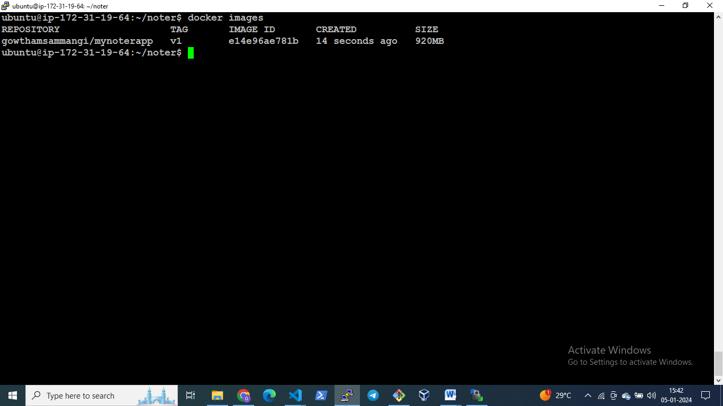

Task3:push to dockerhub

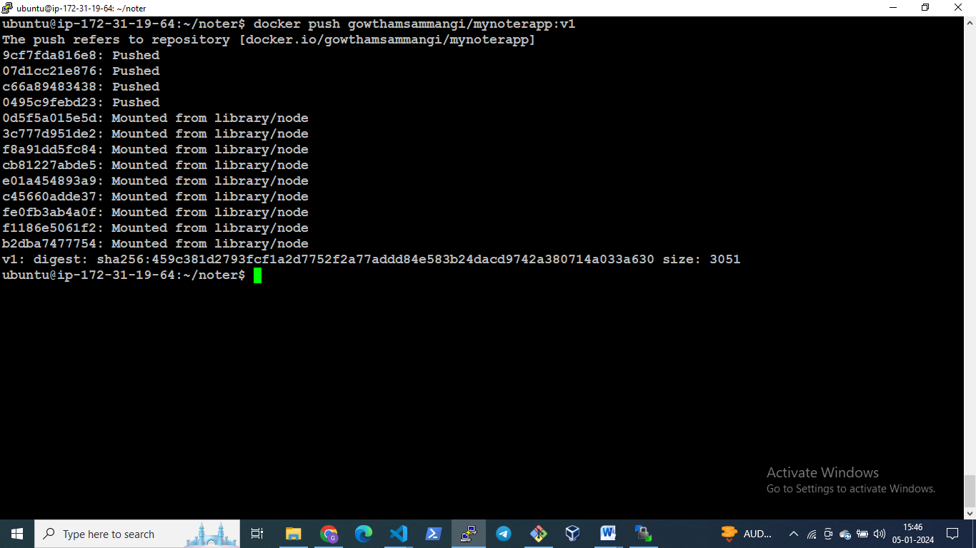

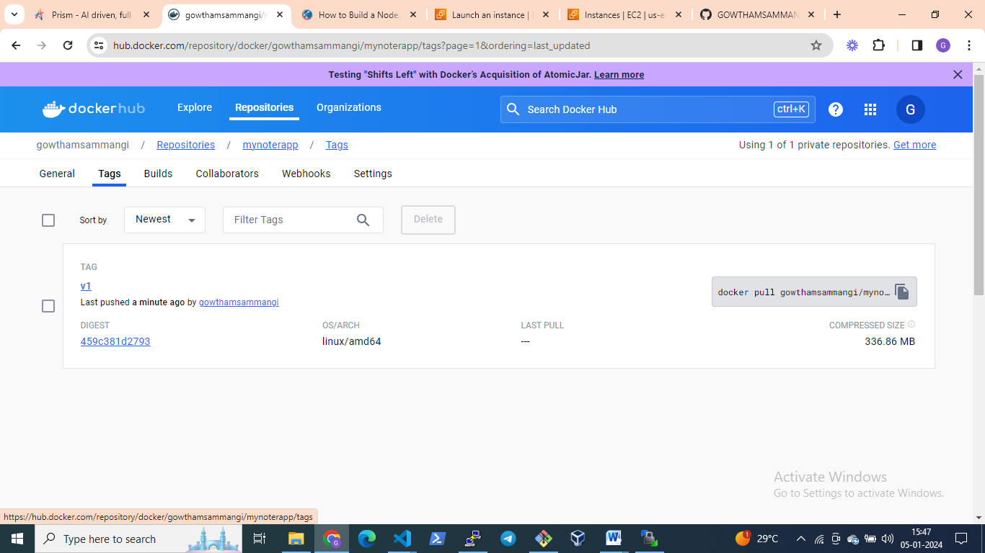

Task4:docker pull

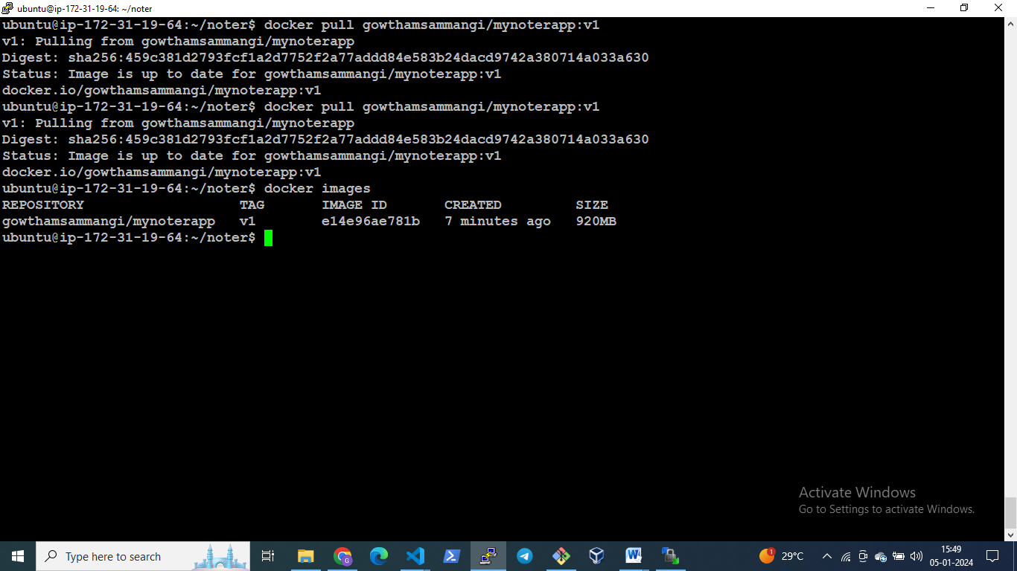

Task5&6:Run a container and create a file version2 inside it

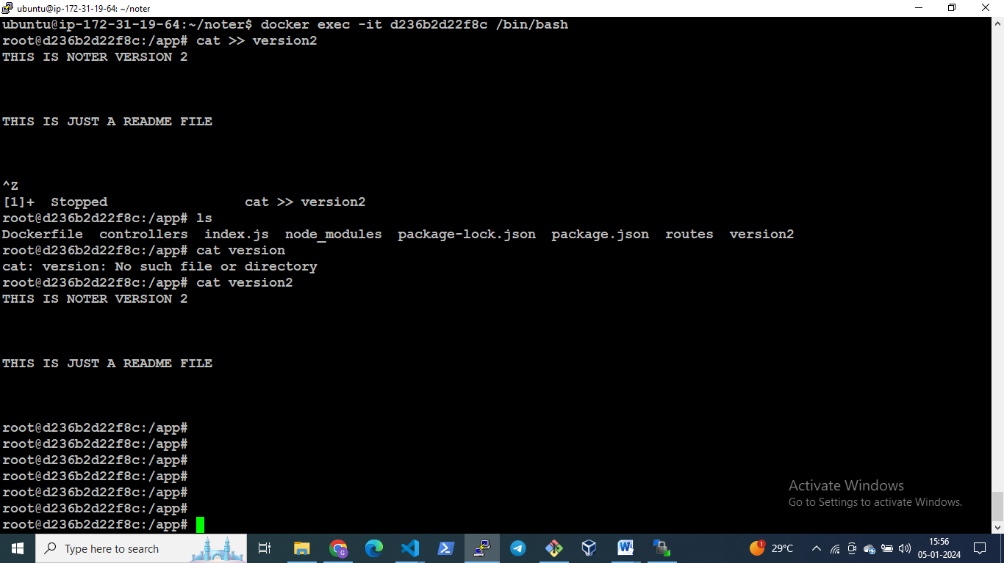

Task 6 &7: Docker commit,tagged to v2 and pushed

docker tag gowthamsammangi/mynoterapp:v2 gowthamsammangi/mynoterapp:v2

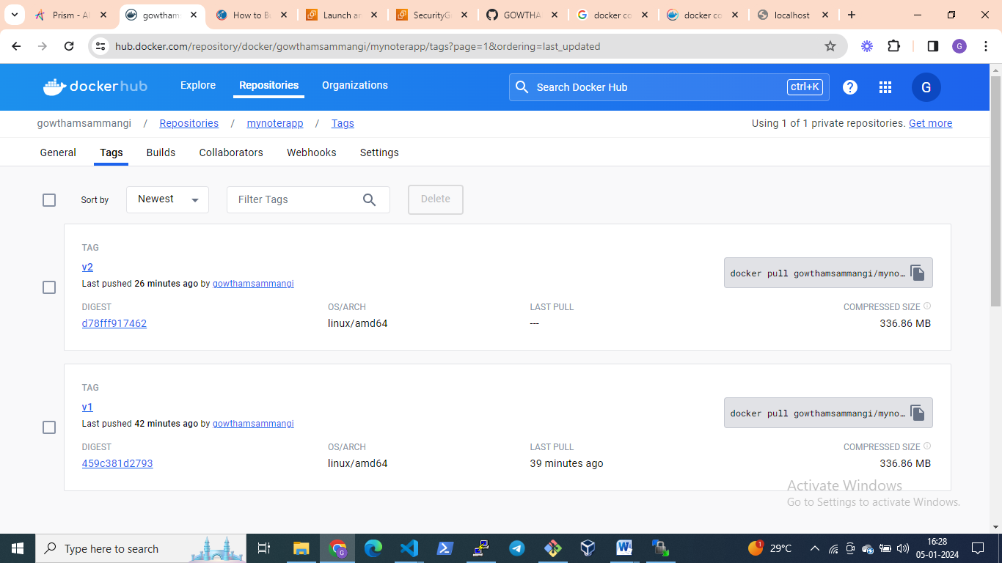

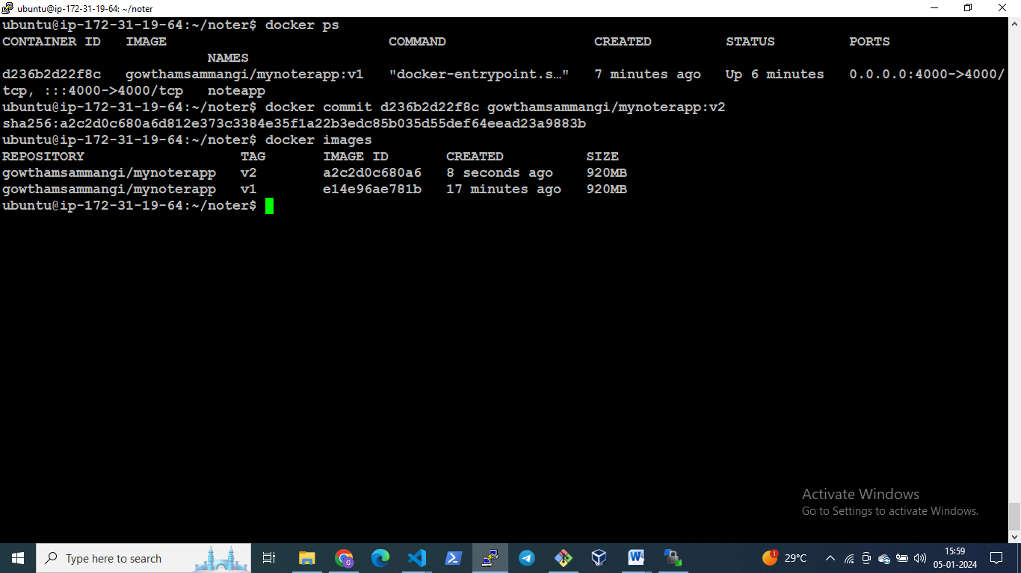

Task 9:Docker compose file

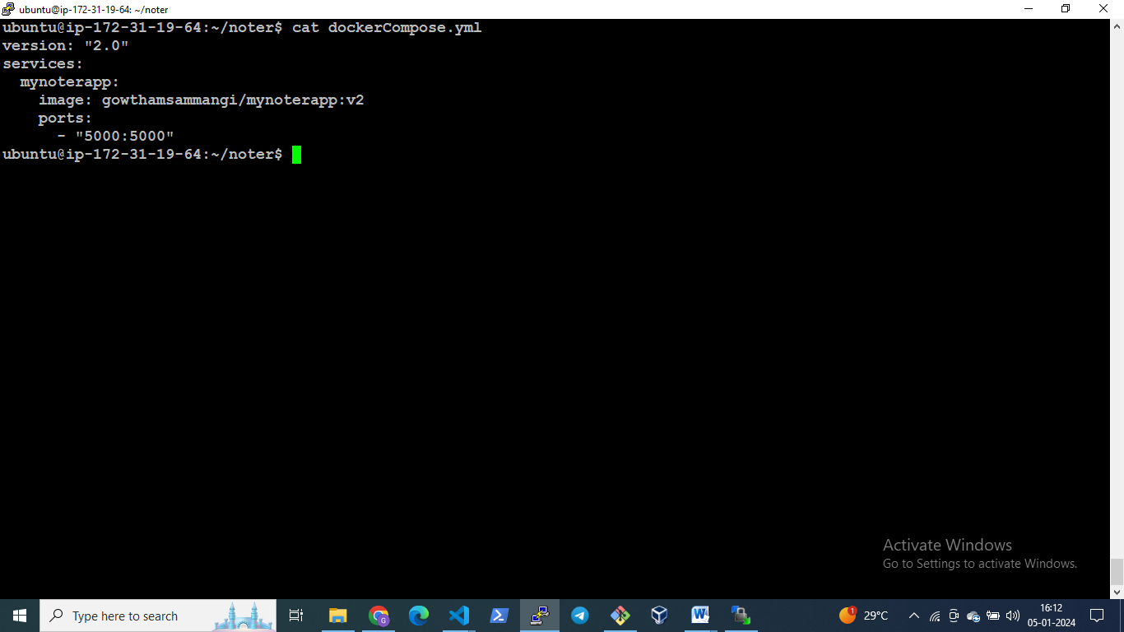

Task10: Run the application using docker compose

